Spring 2021 Dear Museum Friend,
The Middlesex County Museum and Historical Society, Inc. is devoted to fostering the procurement, care, study, and display of objects that are of lasting interest and value to the history and culture of Middlesex County. In addition, the Museum strives to enhance and further the education of members of the community of their history and heritage.
This has been a challenging time. The Museum has been diligently observing all safety precautions related to the Covid-19 pandemic while continuing to share exciting programs virtually. One of its main projects for 2021 is to create an exhibition featuring Saluda, a newly designated Historic District, in recognition of its listing on the National and Virginia Landmarks Register. In addition, new signage will be placed in Saluda recognizing the new historic designation.
The Museum will continue with online free educational opportunities related to the rich and long 352 years of Middlesex County’s rich history. Two of the planned presentations for 2021 are one in which the Fairfield Foundation will present its findings of three archaeological digs in Urbanna; and another in which Ms. Sara Woodbury, a Ph.D. Candidate at William & Mary University, will present a program featuring the WPA projects of the 1930’s, one of which resulted in a finding that the Middlesex County Museum and Historical Society, Inc., is the oldest county museum in the State of Virginia. Also planned for the fall is a tour of Locust Grove, a 18th century farmhouse in Topping. In addition, the Museum will be opening the Historic Clerk’s Office as an information center for visitors and residents, Monday through Friday.
In the past, the Museum has had close collaborations and working relationships with Museums of Middlesex (MOM) and Arts in the Middle (AIM.) These relationships will continue as the three entities join forces to better serve the needs of Middlesex County and its citizens. Also, for the first time, MOM will have a presence during the AIM Juried Fine Arts Festival on June 5 and 6, 2021.
The private sector is the main source of income for the Museum. In order to continue maintaining and expanding its mission, the Museum needs your financial support. Your contribution and willingness to become a member of the Museum will help us secure, explore, preserve, and share Middlesex County’s unique 352 years of history. The Museum is a 501(c)(3) tax deductible organization. Please make a contribution today.
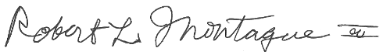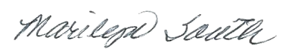
Bob Montague, President Marilyn South, Executive Director

