SOME NOTES ON THE GRYMES FAMILY
OF

MIDDLESEX COUNTY, VIRGINIA

by

J. Randolph Grymes, Jr. Orange, Virginia
April 1994

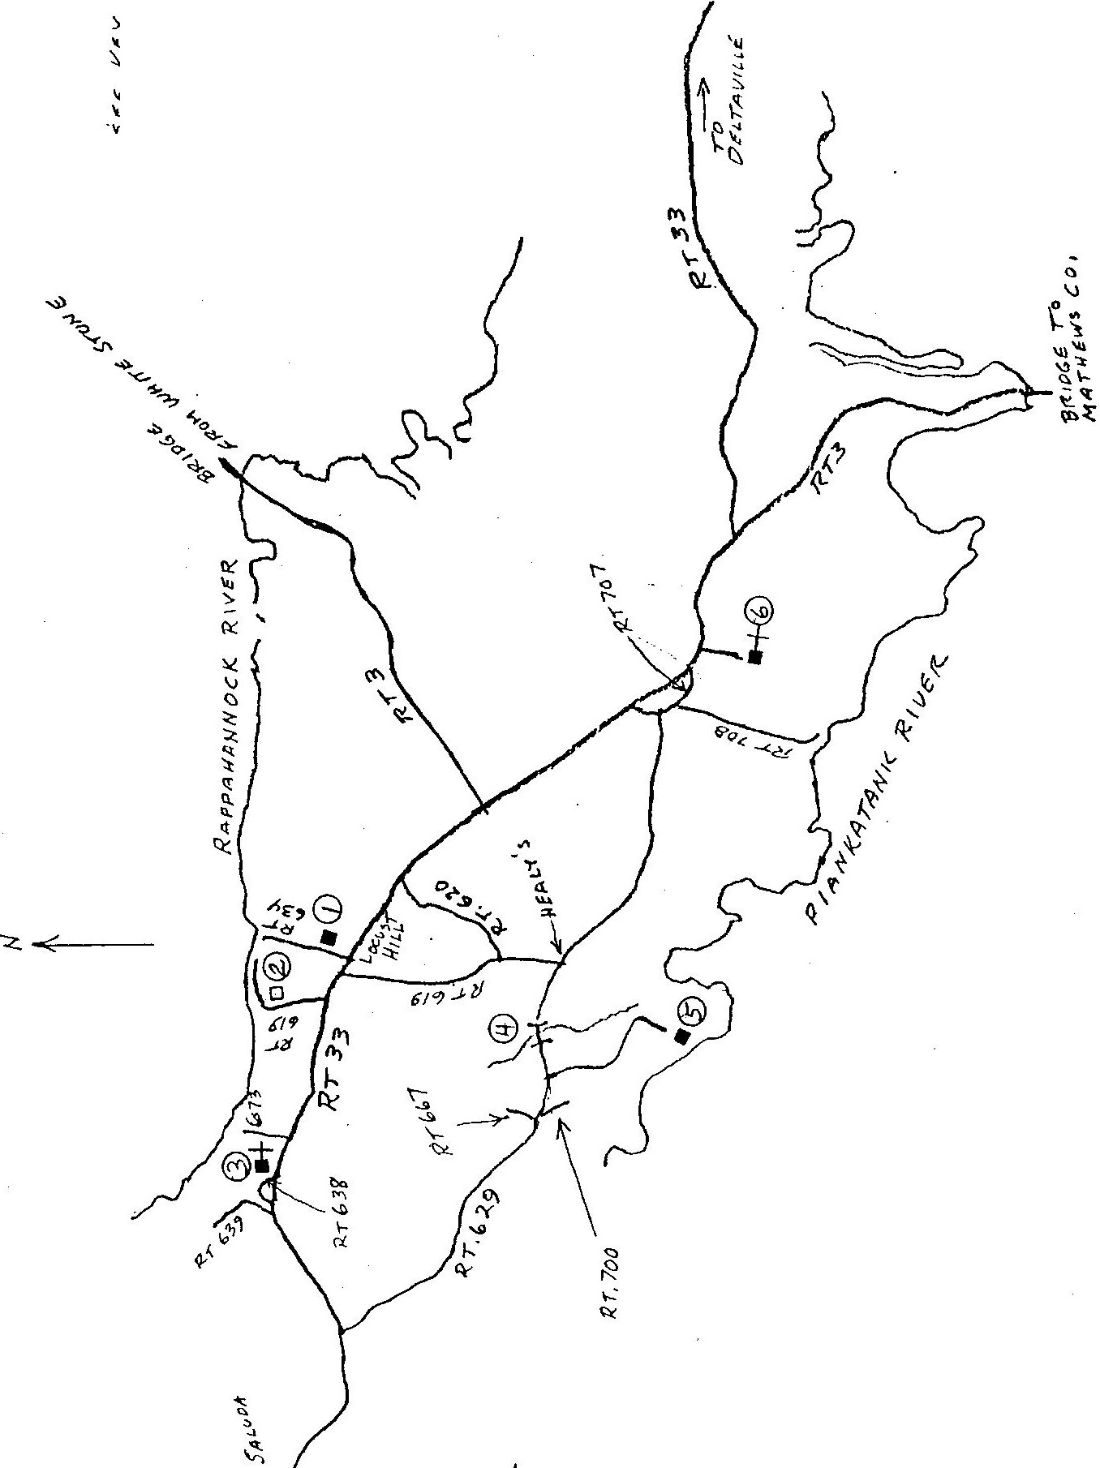

)..Q..
�i

lq
\,
'V)

....
�
()
�
,).-.._...
e '(:
''·
\(J \; \
� �
""'
......
'.::::.

KEY TO CIRCLED NUMBERS ON MAP

- "Marsh Pungo" Some say this was part · of a wing of "Brandon," others· say it was a dependency of the main house at "Brandon." Support for it being a,wing .of the main house is ·that) of its three dormersJthe two nearest the ends of ;the hou e are not equidistant from the end of the house. Also it has been stated that its width and depth meas4rements match that of the wings as sketched in an early insurance policy. It was moved_ from its si e at "Brandon" to its present location, probably ih the 1850's.

- Site of "Brandon." 1800's.
The main house.burned in the middle

- Christ Church - This was the main church of Christ,Church Parish after Middlesex was separat d from L aster County. ·
- My Lady's Bridge - Whil rs tucy (Lu J ll) Grymes was being - transported by chair from·"Grymesby" one of the servants slipped while crossing this stream and fell causing Mrs. Gryme to get her feet wet. Aft·erwards Col. John Grymes had a bridge built over the stream and it became known as "My Lady1s Bridge." On· Virginia Highway -:Department maps the swamp through which this stream flows is named My Lady Is Swamp. .

- The Segar horn ; "Woodfarm," earlier known as Grymesby." Here are loca-t_ed some·of the e.ar1iest marked graves in.. Mfddlesex County, those of John Grymes (1660-1709), his w'ife, Alice. Townley (d.1710), and their daughter Ann (or Anna) (c.1719-1735). The_ original . house at "Grymesby" was probably located in the field near.the cemetery. Mr. Randolph Sega who died in January 1993 had told me that he had found many bricks w en plowing that field.

- Methodist Church. Before the Revolution this was the lower· chu ch of Christ Church Parish.

l

Chart no.

.20 Charles 6ry1es ,Rev.

21 John 6ry e(sl Rev.
:

:B //1612 Rainha1, Kent, Engla:22 Elizabeth??
18 John 6ry es :N after 1655
. lD c.1663 Va.
:B //1660 prob.Gloucester Co.,:
:M bef.1691 l121b Katherine (unknown)
:n 28 ug 1709 "Sry1esby', Mid'-----------------------------:
B

16 John Grymes ,Col.
-----------------------------
lB //1691 Gloucester Co.,Va. l
lN 22 ec 1715
)
N after 1655
D

207 Lawrence Townley

:o 21 Nov 1748 "8randan"Niddlel
119 Alice Townley
'
B
N bef.1691
.-----------------------------:
'-----------------------------
D

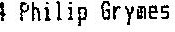
:B 11 Mar 1721 "Brandon• an Ra
lM 18 Dec 1742 Willia1sburg, V
:n 2B Jan 1762 'Brandon•
D //1710 '6ryfieshy' Middlesex'-----------------------------:
8
N D
86 Philip Sr. Ludwell
-----------------------------:

lB //1638 England
72 Philip Ludwell lN //1667
lB9 Jane Cottingha1
'-----------------------------

.-----------------------------:0 d '6reenspring'Ja es City C
:B 04 Feb 1672 Carter's Creek,:
:H l87 Lucy Higginson
:D 11011726-7 '6reenspring"nea'-----------------------------:
B

117 Lu,y Ludwell H //1667
'-----------------------------

'-----------------------------: D
B 02 Nov 1698
N 22 Dec 1715
D 03 Har 1749 "Brandon• Hiddll .-----------------------------:

lB
:73 Hannah Harrison lN

' :0
B
N
: .
'-----------------------------

D '-----------------------------:
B

N '-----------------------------
D

3

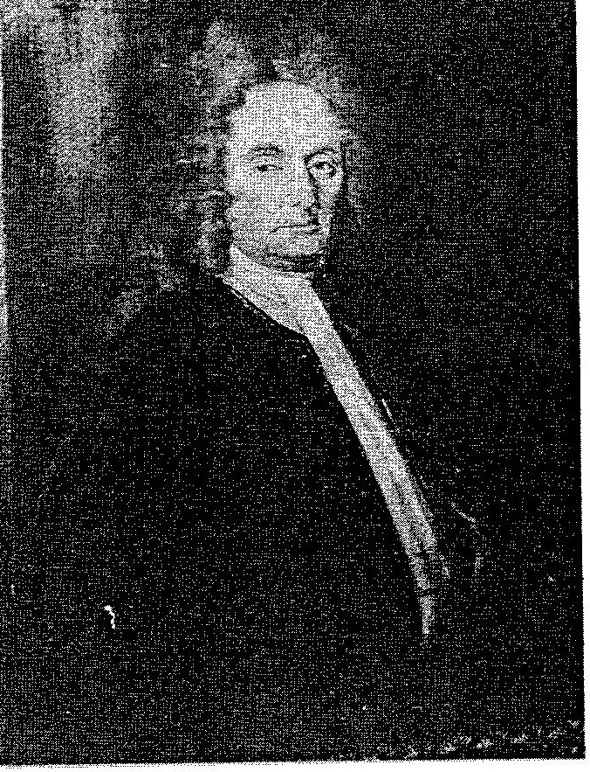

Col. JOHN GRYMES (1691-1748)
of Grymesby and Brandon Middlesex County, Virginia
Receiver-General of the Colony of Virginia
(1723-1748)

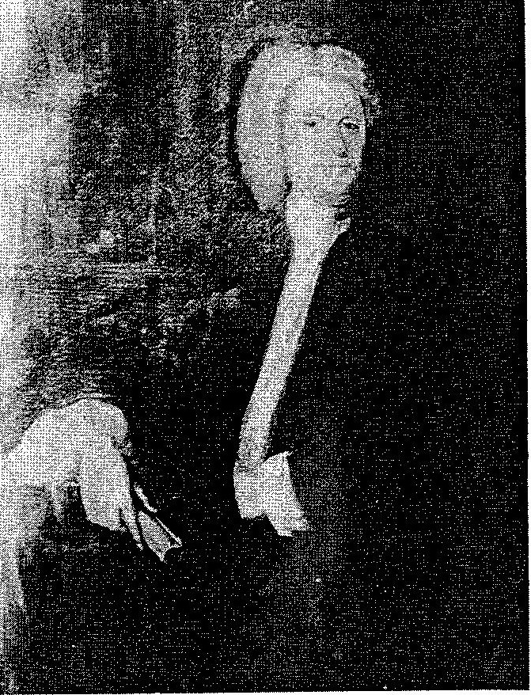

PHILIP GRYMES
(1721-1762)
of Brandon and Grymesby Middlesex County, Virginia
Receiver-General of the Colony of Virginia

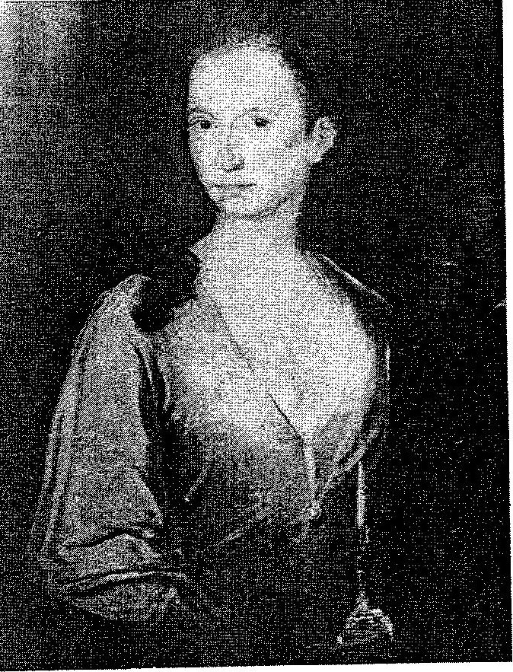

MARY (RANDOLPH) GRYMES
wife of
PHILIP GRYMES OF Brandon and Grymesby Middlesex County, Virginia

HUSBAND: John Srymes ,Col. iRN=!6l
Born //1691 Place Gloucester Co.,Va.
Harr 22 Dec 1715 Place
Died 2! Nev 1748 Place "Brandon"Middlese Co.Va.!see Note 11 HUSBAND'S HUSBAND'S
FATHER: John 6ryraes (RN=!Bl MOTHER: Alice Townley (RN=19l

WIFE: Lucy Ludwell IRN=17l Born 2 Nov 1698
Died 03 Mar 1749 WIFE'S
FATHER: Philip Ludwell !RN=72l

Place
Place "Branden• Niddlese Co., Va.

WIFE'S
MOTHER: Hannah Harrison fRH=73l

M/F CHILDREN

WHEN BORN

WHERE BORN

FIRST tlt\RR!ASE

WHEN DIED

1 F Hannah Grymes (RN=235)
23 Feb 1717

Henry Poth;r ,Dr. !RN=236)

2 11 John Srymes ,son of Cal. John 6. HlN=242) 01 Jan 1718 l'lidd!esex Co.,Va.

3 F Lucy Srymes dau. of Col. John {RN=239) 23 Feh 1717 Hiddlese: Co.,Va.
20 Jun 1740

Dec. 5, 1737/8
Carter Burwell ₁Col, IRN=2401

4 11 Philip 6ry1es !RN=l41
1! Mar 1721
"Brandon•
18 Dec 1742
20 Jan 1762

on Rappahanr:ock, Middlese Co., \la. Nary Rando!ph !RN=!5!

S H Charles 6ry!!les ,son of Col. John S. (RN=241) 31 May 1723 "Brandon"on
Rappahannock,Mid. Co. Va.
24 I!ec 1727

b F Alice 6ry es !RN=243l
Hl Aug 1724
"Brandon• Mid.Co.,Va.
31 Dec 1741
11 J2n 1746

7 M Benjal!lin 6ry11es ,son of Col. John 6. !Rt-1=234) 19 Jan 1726 "Brandon"Hid.Co.,Va. E F Sarah Grymes dau.of Col. John 6. IRN=2451 27 Jan 1729 1Brandon"Nid.Co.,Va. 9 H Charles 6ryaes ,2nd.son of name, (RN=4!3l 01 Har 1730 "Brandon• Hid. Co.,Va.
1
Hl l'! Lud ell 6ryB1es ,son of Col. John 6. !RN=233! 26 Apr 1733 "Brandon• Hid. Co.,Va.
Mann Page IRN=244)

0! Nov 1747 c 1776
Elizabeth Fitzhugh IRN=451l

02 Oct 1731

19 Sep 1732

1756 bef. 1795
llary Dawson lR1l=472l

SOURCES OF INFORMATION

H-1-or 6ry esby1Mid.Co. 2-1-REf:Tel!lp!e Ch. records
4-1-Ref:Bible pgs.SMe Library.
OTHER NARP.IASES

7-Priscil]a Rcctes (RN=453l

7

HUSBAND: Philip 6ryees {P.N=14l Born 11 Mar 1721
Narr 18 Dec 1742
Died 20 Jan 1762 HUSBAND'S

Place "Brandon' on Rappahannock, Middlesex Co.₁ Va. Place Willia sburg, Va.
Place "Brandun'
HUSBAND'S

FATHER: John 6ry11:es 1CCJ1.(RN=!6l
MOTHER: Lucy Ludwell lRN=17l

WIFE: Mary Randolph fRN=15J
Born c 1725
Died 10 Jan 1768
WIFE'S

Place "Tazewell Hall"1 Williatsburg1 Va.
Place Wi liamsburg,Va.
WIFE'S

FATHER: Juhn Randolph ,Sir lRN=74l
MOTHER: Susanr,ah Beverley !RN=75l

r.fF CHILDREN
WHEN BORN
WHERE BORl-l
FIRST NARRIASE WHE DIED

- F Lucy Srymes dau. Philip (RN=253l 24 Aug 1743
Williamsburg, Va.
29 Jul 1762 18 Sep 1834
Thomas Nelson ,6ov. (of Yorktown)
!RtM54J

- l'l John, son of Philip 6rymes !RN=!358l 20 liar 1745 Brandon

- N Philip Ludwell son of Philip Grymes (RN=255l 05 Apr 1746 "Brandon',
Middlesex Co.Va.

- "John Randolph son of Philip Grymes (RN=256l 07 Jun 1747 Brymesby

- ti Charles, son of Philip Brymes (RN=257l 17/ 1/1748/9 6rymesby
23 Jun 1745

38 May 1778 18 May 1805
Judith Worteley !RN=950l

20 Nay 1779 23 Sep 1796
Susanna Beverley (RN=1357l

- " Benja!iin Grymes !Rtl=12l

- F Susanna 6ryaes !RN=258l

,cf •carter's Srove• and "Carter's Hall'

- F Mary Sryses (RN=260}
10 Aug 1750

04 Mar 1753

12 Feb 1754
'Brandon• Oct. 4₁1773 13 Aug 1805
en Rappahar:noc , Middlesex Co.,Va. Sarah (Sallyl Robinson (RN=13)

Brandon 28 tlar 1772
Nathaniel Bur ell

!RN=259l

Oct. 1774
Robert Melson ₁ofYorktoijn
!P.N=261l

- H Peyton 6ry es ,son of Philip (RN=262i 04 Apr 1756 Brandon
28 Jun 1756

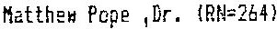

OTHER MARR!AGES
1B F Elizabeth Grymes lRH=2b3l | 03 Aug 1757 | Branden
SOURCES OF INFORMATION
H-1-Ref:Bible pgs.S e Library. 2-!-Ref;Judith 6. bibie
3-1-ef:Judith 6. Bible,Swe Lib. 4-1-Prob. bur. date, n t death.
 |  | 8

SOURCES Of INFOP.NAT!ON OTHER MARRIAGES
4-2-Ref:Judith 6. bible
4-3-Ref:WHQtr.1Y.21,t2
5-1-Ref:Judith 6. bible
6-1-Ref:Bible W N
6-2-P.ef:W!N £!.
7-1-Ref:Judith 6. bible
7-2-Bapt.13/04/1753
7-3-Ref:WIHB
8-1-Ref:Judith 6. bible
8-2-Bapt.03031754
8-3-Ref:VHSN,v.28100.3
9-1-Bapt.09/04/1756
9-2-Ref:Judith 6. bible

9

HJSCRIF'TIOl'-.IS ON TOMBST□r,JES AT "GF:YMESBY"
JOHN GRYMES (1660-1709):
Here lieth Interred The Body of Mr. John Grymes, who departed This Life in the Year
Of our Lord 1709.

AL I CE GFNMES

Here lieth Interred the
Body of Mrs. Alice Grymes, who Departed This Life in the Year of
Our Lord, 1710.

ANNE GRYMES

Here lies the Body of Mrs.
Anna Grymes, Daughter of
Mr. John & Mrs. Alice Grymes, Who lies near this Place. She Departed this Life the 17th day
of December Anno Dom. 1735,
In the 16th year of h r Age.

Alice Grymes, wife of John Grymes (1660-1709) was the daughter of Lawrence Townley and granddaughter of Augustine Warner, Sr. of "l•Jarner. Hall 11, Gloucester County.
In addition to their daughter, Anne, John and Alice Grymes had tvm sons: John (1691-1748) of "Grymesby" and "Brandon" and Cha1 1es (d. 1743) of "Morattico."
INSCRIPTIONS ON TOMBSTONES AT CHRIST CHURCH <MIDDLESEX) JOHN GRYMES (1691-1748):
HERE LIES INTERRED
The Body of the Honourable JOHN GRYMES, ESQR.,
Who for many years acted in the Public affairs of this Domi­ nion with Honour, Fortitude, Fidelity to their Majesties King George I and II. Of the Council of State, of the Royal Prerogative, the Liberty and Property of the subje t
A ZEALOUS ASSERTER. .
On the seat of Judgement slear, sound, unbiassed. In The Office of Receiver General Punctual, Approved.
Of the Coliege of WILLIAM AND MARY, an Ornament Visitor, Patron, Beneficient to all. A support to.the Distressed, A Pattern of True Piety, Respected, loved,
t-evered.

Lamented by His Family, Acquaintance,
He departed This Life the 2d Day of Nov.
57 year of His Age. (One transcription has death date of 21 Day of
Ft-i ends, 1748, in the

Nov.)

/D

TOMBS AT CHRIST CHURCH (con"t.>
LUCY (LUDWELL) GRYMES:
THIS MONUMENTAL MARBLE
In Remembrance of all that could endear ye living and make the dead lamented*** for Benevolence and Truth
IS PLACED HERE
Over the Remains of an Excellent Person ***ial *is
better and more lastingly Recorded ***sed, Tes-timonials of the Wise and Good.
The Filial Piety of Her earlier years was an earnest of That Social Excellence, which all Her after life United to adorn the wife, the Parent and the Friend.
GENEROSITY
***s best Motive. An Unbounded Charity, ***ts Only Guide Virtuous Prudence, gained Her as Many Friends as she had Acquaintance.
HUMILITY
***st sense of Her Maker and Herself*** from Whence it arose, preserved Her from the Envy usually attendant.
ON HER EXALTED STATION.
And procured Her the undissembled Affections of all Ranks Who admired in Her Goodness without Ostentation,
Elevation without Pride, and without Meanness Conde­ sceneion even to the lowest of Her Inferiors.
such was
MRS. LUCY GRYMES RELICT
of the Honourable JOHN GRYMES, ESQR.
(Whose body reposes near this of His beloved Wife.) DAUGHTER
of the Honourable Philip Ludwell, Esq.,
PARENT
Of a numerous and deserving Family.
On the 3d day of March, in the Year of our Lord 1749 and in the 52 Year of Her age, the Divine Commmand
summoned.Her to receive the Rewards of a well spent life.
She Obeyed with ready and devout Resignation; And, having given and Illustrious Pattern
OF LIVING WELL,
She taught the next great lesson, HOW TO DIE.

JI

Reference the portrait of the Grymes children which is now owned by the Virginia Historical Society:

The children shown in the portrait are four of the children of Philip (March 11, 1721 - 1762) and Mary (Randolph) Grymes (d. at Williamsburg, January 10, 1768) of Brandon and Grymesby, Middlesex County Virginia. Mary was the daughter of Sir John Randolph (1693 - 1737) of Tazewell Hall, Williamsburg, Virginia and his wife Susanna Beverley. Philip and Mary were married at Williamsburg on December 18, 1742. Their children in the portrait (from left to right) are:

Lucy who was born at Williamsburg August 24, 1743 and died September 18, 1834. She is buried at Fork Church, Hanover County. She married, July 3, 1762, Thomas Nelson of Yorktown, Governor of Virginia (June 12 - November 30, 1781), Major General commanding Virginia Militia at the siege of Yorktown, and signer of the Declaration of Independence.

John Randolph who was born at Gryrnesby, June 7, 1747 was buried in England (St. Michael's Place, Kensington, London) September 23, 1796. On May 20, 1779, he married Susanna Beverly Randolph, daughter of John Randolph, the loyalist, who moved to England because of the Revolution. Both John Randolph Grymes and Susanna Randolph were grandchildren of Sir John Randolph and his wife, Lady Susannah (Beverly) Randolph. J. R. Grymes' wife, Susanna, was probably the burial (Susannah Beverly Grymes) of October 12, 1791 although there was a burial of Susannah Grymes, May 10, 1788. Four of J. R. and Susanna's children were baptized: John Jennings, May 7, 1780; Ariana Maria, March 9, 1781; Mary Beverly,
August 24, 1782; Charles Wyndham, March 26, 1784.
John Randolph Grymes sided with the English in the American Revolution and in 1776 joined Dunmore at the head of a troop. He joined the Queen's Rangers under Simcoe and served with credit as a Major until he went to England in 1778.
Some accounts state that he later returned to Virginia and
became a wealthy planter in Orange County. His name can not be found in Orange County records, and according to records of St. Mary Abbots Church Registry, Kensington, W. 8, London he and his wife are buried there. (Ref: W & M Quarterly, v. 21, i 2, April 1941, pages 174, 175.)
Philip Ludwell who was born at Brandon April 5, 1746 and died May 18, 1805. He was educated at Eton and was a member of the House of Burgesses from Middlesex for the sessions of May 1769, November 1769, and May 1770. In the next year he vacated his seat by accepting the office of sheriff. He was a member of the House of Delegates from Middlesex in 1778 and 1802-03, and was chosen a member of the Council of State 1803. He married first Sarah, daughter of Attorney General John Randolph and had no issue. He married secondly, May 27, 1773, Judith, daughter of Ralph Wormeley of Rosegill, Middlesex County. In addition to children who died young, they had a daughter, Jane, who married Samuel William Sayre, July 23, 1804, and died at Brandon, January 1, 1806.

GRYMES CHILDREN PORTRAIT (con't.)
Charles who was born at Grymesby January 17, 1748. He and his younger brother, Benjamin, inherited 12,000 acres of land in Culpeper County in the portion that is now Madison County. This was a grant of lapsed land to their grandfather, Col. John Grymes. They divided this land into many tracts and sold it.
Charles seemed to have financial difficulties. The following is a letter to his brother Benjamin dated March 17, 1784:
I now send Mr. Leyton to inform you I am in the Sheriff's hands for a considerable sum of money My effects will be executed immediately unless you return me 300 pounds by the Bearer If you have not the rnoneydispose of as many negroes as will pay the present demand. I desire you would get the money from Willis - I expect some more executions to be offered to me in a short time therefore you may sell the amount of 600 pounds. Mr. Leyton must have a girl of about 13 years old. Mr. Leyton will leave & take my horses down which you have
Love &c attend the family
C. Grymes

.In April of 1783 Charles twice asked Benjamin to·sell items off of Charles' plantation apparently to pay debts.

The other children of Philip and Mary Grymes were:

John who was born at Brandon March 20, 1745 and died June 23, 1746.

Benjamin (of Vaucluse) who was born at Brandon August 10, 1750 and died August 13, 1805 at Auburn, Stafford County, the seat of his son-in-law, William Bayly, Esq. Benjamin married Sarah (Sally} Robinson.

Susanna who was born at Brandon March 4, November) 28, 1772, Nathaniel Burwell of City County, and later of Carter Hall, County.
1753, married March (or "Carter's Grove'" James Frederick (now Clarke)

Mary who was born at Brandon February 12, 1754, married Robert Nelson of Yorktown, October 1774.
Peyton who was born at Brandon April 4, 1756 and died the following June 28.
Elizabeth (Betty) who was born at Brandon August 3, 1757. She married Dr. Matth w Pope, of Yorktown, a surgeon in the American Army during the Revolution.

J. R. Grymes, Jr. Orange, Va.
April 1994

/.3

A SHORT BIOGRAPHICAL SKETCH OF THE REVEREND CHARLES GRYMES, IMMIGRANT

By: J. Randolph Grymes, Jr.
227 East Main Street Orange, VA 22960

June 5, 1991

GRYMES, CHARLES, REV. - Born Rainham, Kent,, England of Rev. John Gryme(s) and his wife Elizabeth.
Pembroke College, Cambridge University where he was 1631.
in 1612,
Educated admitted
son at in

Emigrated to Virginia probably in early 1640's and was Rector of New Poquoson Parish (near present-day Yorktown) apparently beginning February 20, 1644/5. He definitely was Rector there by December 20, 1645.
Probably Rev. Charles Grymes left England because of the persecution of his father, Rev. John Gryme(s), Rector of St. Peter's Church, Ightham, Kent 1616-1644. One account of Rev. John Gryme(s) difficulty was: "During the troubled days of the reign of King Charles I, John Gryme was a cause of a local uprising in 1643. Ordered to take and impose on his flock an oath of allegiance to the two Houses of Parliament, this 'Kentish Sir Byng stood for his King, Bidding the crop-headed Parliament swing', and refused to obey. A party of horse came to arrest him and take him up to Parliament whereupon a number of Ightham people and others 'gathered together with halberts, swords and staves, and would have rescued him'. This they failed to do, but the tumult increased, and their number swelled at Sevenoaks to 2,000. After a vain attempt at mediation by Sir Henry Vane, Senior, the Parliament sent down two regiments of foot, a regiment of dragoons and some troops of horse. The local forces were driven towards Tonbridge, where 'having pulled down Hildenbridge, a quarter of a mile off the town', they made stout opposition for some time, but were finally overpowered."*
Rev. John Gryme was arrested and imprisoned. He never came to trial but died in prison. His will, written in August 1643, just one month after his arrest, was proved on 22nd March 1644/45.**
Charles obtained extensive land grants in Lancaster County beginning in 1653 on both sides of the Rappahannock River. (These land grants were in present day Caroline, King George, Lancaster, Middlesex and possibly Richmond Counties.) Sometime after 1655 he married Katherine Dedman who appears to be the widow of Henry Dedman. She had at least one daughter also named Katherine Dedman who married Robert Taliaferro, the immigrant. Rev. Charles and Katherine Grymes had one son, John, who was born in 1660.
Rev. Charles Grymes died before March 16, 1663 and his widow was living in August 1678.

* Included in an article entitled Casualty of the War about Rev. Charles Grymes and Rev. John Gryme(s) by Mrs. Wilma Picton of Ightham, Kent in Northwest Kent Family History Society Journal. Mrs. Picton was quoting from The History and Records of Ightham Church by Edward Harrison who attributed the article to Rushworth's Historical Collections.

** Private correspondence with Mrs. Wilma Picton.

(See attached for more detail and other sources of above information.)

l

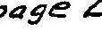

References pertaining to the Rev. Charles Grymes, Immigrant, 1612 - c.1663:

Born 1612 Rainham, Kent son of Rev. John Gryrne(s) and his wife Elizabeth.
One brother, John, b. Rainham 1611 and died at or soon after birth. Sisters: Elizabeth b.Rainham 1614
Anne b. Rainham 1614 twin of Elizabeth
Sarah b. Rainham 1616 m. Raphe (Ralph) Dawling (they had
one dau., Sarah) Jane b. Ightham (pronounced "Item"), Kent 1617, d.1640,
bur. St. Peter's Church,Ightham, Kent. (Rainham, Kent and Ightham, Kent Parish Registers.)*

GRIME, JOHN. Matric. pens. from Trinity, c.1595. s.of Robert, Yeoman. B. at Horning, Norfolk. Schools, Coltishall and Oxnead. Migrated to Caius, Jan. 25, 1596-7, age 17. Scholar, 1597-1600;
a.A. 1598-9; M.A. 1602. Ord. priest (Norwich) June 13, 1605. c.
{Curate) of Teversham, Carobs. V. (Vicar) of Rainham, Kent 1609.
- (Rector) of Ightham, Kent 1616-1644. Will (P.C.C.
<Prerogative Court of Cantebury>) 1645. Probably father of Charles (1631). (Venn, John Alumni Cantabrigiensis.) *
GRIME or GRIMES, CHARLES. Adm. sizer (age 19) at Pembroke, 1631.

- of (Op. cit.) *
of Ightham, Kent (?John of 1595). Matric. 1631.

"Feb. 20, 1644/5 Minister inducted for Poquoson." Notes from Council nd General Court Records, 1641 - 1659 by Conway Robinson, Esq., <Gen'l Court Minutes 12, p.369.> (Va. Maga. History and Biog., v.8, p. 65-73.)
"The General Court Minutes record that a minister had been inducted for New Poquoson Parish on the 20th of February 1644/5. He is known to have been the Reverend Charles Grymes." (Mason, G.C., Colonial Churches of Tidewater Virginia, Whittet & Shepperson, Richmond, 1975, p.230.)

<POQUOSON is an Indian name for marsh or low ground.
p. 441.)> New Poquoson Parish was on the south of Charles) River near its mouth euui proM:slal i11eitt11Je.i Tgx , •- It was northwest of Old Poquoson Parish. map.)
(VMHB v.1,
the York (or the site 91( (From a 173?

20 Dec. 1645 "Whereas Thomas Waldoe was by the Churchwardens of the w Poquoson presented for an abuser of the Church and Minister, & for not receiving the sacrement The Court doth therefore order him the said Waldoe to bring certificate under the hand of Mr. Charles Grimes minister of the said parish of his reformation of the said abuses to the next Court otherwise to be censured by the Court for the same." (MSS 3P9465g, Va. Historical Society. From York County Records, #2, pg. 55. Court of 20 December 1645.)
Children of Rev. Charles and Katherine Dedman (or Deadman or

Rev. Charles Grymes - references (con't) page 3 Debham) Grymes:
John born 1660 d. Aug. 28, 1709 (Va. Mag. Hist. v.27,12, April 1919.)
Katherine Grymes' previous husband William Dedman (or Debham, or Deadman). died by 1657. The Dedman's had a son William and three daughters. (Noel Currier-Briggs, Sutton-in-the-Isle, Cambridgeshire, England private correspondence via Mrs. Wilma Picton, Ightham, Kent.)*
Their daughter, Katherine, married Robert Taliaferro the immigrant. (Ref. J.B.C. Nicklin, VMHB v.58, #2, p.208-210.)

Note that Mr. J. 8. C. Nicklin in the attached article about Rev. Grymes states that Katherine Grymes' former husband was Henry Dedman who was deceased by June 6, 1655 and that Henry and Katherine had three daughters: Katherine, Ann, and Mary.
(At a later date I will attempt to resolve the above discrep­ ancies concerning Katherine Dedman's family. - J.R.G.,Jr.)
References to Charles Grymes in Land Records from Nugent, N. M. Cavaliers and Pioneers, 1623-1666, Genealogical Publishing Co., Baltimore 1979:

18 Oct. 1653 Charles Grymes, Clerk, 1,000 acres Lancaster Co. UponNWside of Moraticon Creek beg. upon easternmost side of a small branch which divides this and land of Thomas Steevens, extending E by N etc. For trans of 20 persons. Pg.254. (Patent Book 3, pg. 74)

16 Nov. 1653 Charles Grimes 600 acres Lancaster Co. bounded on NW side with Nyemcock Creek (now Urbanna Creek - ed.), SW upon a swamp, etc. Transport of 12 persons. Pg. 282. (Patent Bk. 3, p.228)

Dec. 1653 Charles Grymes, Clerk. 960 acres in Lancaster Co. on North side of Rappahannock & NW side Corotoman Rivers. For trans. of 19 persons. Pg.254. (Patent Bk. 3, pg. 73)

26 Dec. 1653 Charles Grymes, Clerk, 1,000 acres in Lancaster Co. Upon N. side of Rappahannock River, bounded SW upon the head of Fleet's Creek, on the NW side of Rappahannock Town. For trans. of 20 persons. Pg. 254. (Patent Book 3, pg. 73)
i Sept. 1654 Mr. Charles Grymes, Cl., 600 acres Lancaster Co. on S side of Rappahannock River. Beg. at a Pequoson or sunken land over against the Douges land above Nazemum. For trans. of 12 persons. Pg. 296. (Patent Book 3, ppg. 297)
12 Dec. 1654 Richard White, Cooper, 500 acres within the freshes of sd.(?) river opposite to Nazemond Towne, adj. land of Charles Grymes & Abraham Moone. Pg. 300. (Patent Bk. 3, pg. 310.)
l Dec. 1656) Mr. Charles Grymes, Clerk, 1,000 acres Lancaster Co.

Rev. Charles Grymes - references (con't) page 4

upon NW side Moraticon Creek. Renewal of patent dated 16 Nov. 1653. Pg. 340. (Patent Bk 4., pg 68 <99>)

3 Dec. 1656 Mr. Charles Grymes, Clerk, 600 acres, Lancaster Co. NW upon Myem Cocke Creek. Renewal of patent dated 16 Nov. 1653. Pg. 340. (Patent Book 4, p. 68 <99>)

8 Oct. 1657 Charles Grimes 1000 acres si Rappahannock River, SW upon head Rappahanock Towne called Fleets Creek.
26 Dec. 1653. Pg. 354. {Patent Bk. 4,
Lancaster County, upon N of a creek upon N. side Renewal of patent dated
p. 125 <185>)

8 Oct. 1657 Charles Grimes 960 acres Lancaster Co. above. Same page as above.

8 Oct. 1657 Charles Grimes 600 acres Lancaster Co. patent dated 4 Sept. 1654. Same page as above.

8 Oct, 1657 Charles Grimes 600 acres Lancaster Co. above.
Renewal as Renewal of Renewal as

2 Dec. 1657 Richard White, Cooper, 500 acres Lancaster Co. Opposite to Nansemond Towne NE upon land of Mr. Charles Grimes. Pg. 355. {Patent Bk. p.132 <195>)

20 June 1659 Mr. Cuthbert Potter, 5380 acres on the N & S sides of the great swampe or Pacoson which divides the counteys of Lancaster and Glocester about two miles above the horse path. 1300 acres beg. on N side of sd. swamp by or nigh Mattapany path that goeth from the plantation of John Curtis & adj. trees supposed to belong to Mr. Charles Grymes. Pg. 391 {Patent Bk. 4,
p. 278 <379>)

20 Sept. 1661 Cuthbert Potter, Gent. 3672 acres Lancaster Co. on Sunderland alias Boswell's Creek & branch of the greate swamp on S side Rappa. Riv. 1380 acres (of above) about 2 mi. above the horse path & nigh Mattapony path that goeth from plantation of Mr. John Curtis &c. to Mr. Charles Grimes. Vol II, p.15. {Patent Bk. 6, p.15)

S Mar. 1662 Jno. Curtis, 600 acres Lancaster Co. on the head of Nimcock Creek &c. down Hollowbush E.N.E. &c. Granted to Charles Grymes, by him deserted & granted sd. Curtis by order of the Gen. Ct. Pg. 465-6 (Patent Bk. 5, p. 221 <119>)
i Sept. 1663 Thomas Paine (Payne) & John Chinley 2100 acres in (Old) Rappahannock Co. adjacent land of Charles Grimes. Pg. 410 (Patent Bk.4, p.37 <482>)
14 Mar. 1663 Thomas Bryar 300 acres in (Old) Rappahannock Co. upon outermost line of marked trees of Mr. Charles Grimes. Pg.459. (Patent Bk. 5, p. 199 <94>)

Rev. Charles Grymes - references (can't) page 5
16 Mar. 1663/4 George Bryar & Richard Lawrence 3000 acres in Rappahannock Co. on Eastward side of Rappa. Cr. Beg. on sd. Cr. side adj. land of Col. More Fantleroy & opposite to the new plantation of Col. Walker, extending along the Cr. side to land of Charles Grimes, dec'd., bounded by same, land of Mr. Jno. Hull & his own .... Pg. 527. (Patent Bk. 5, p.408 <470>)

17 Mar. 1663 Patent of 3000 acres to George Bryer and Richard Lawrence (Old) Rappahannock Co. Eastward side Rappa. Cr. extending along the creek side to the head of Parson Grymes, by land of sd. Grymes. Pg.467. (Patent Bk. 5 p. 227<138>}

18 Mar. 1663 George Bryer & Richard Lawrence 1300 acres (Old) Rappa. Co., on N side sd. Riv. & Ewd. side of Rapppa. Creek. Adj. to land of Charles Grymes, Clarke, dec'd. Pg. 441. (Patent Bk 5., p. 143 <11>)

1664 John Chinly 200 acres (Old}Rappa. Cr., bounding upon land of Mary Stevens. and Mr. (Patent Bk. 5, p.143<11>)
Co. on Moratico Grymes. Pg.441.

26 Sept. 1664 George Bryer & Richard Lawrence, 1000 acres in (Old) Rappahannock Co. N Side of Rappahannock River, SW upon head of Fleet's Creek upon N, side of Rappahanocke Towne. Granted to Charles Grymes 8 Oct 1657, by him deserted & now granted by order of the Genll. Ct. ----- Pg. 472 (Patent Bk. 5,
p.239 <161>}
1 Nov. 1664 Grant on N. side of Lancaster Co. notes bounding on
I and which was formerly Parson Grimes. Pg. 514. (Patent Bk. 5,
p.371 <406>)
28 Nov. 1664 Grant between Moratico Creek and Farnham Creek adj. land of Charles Grymes. Pg. 485. (Patent Bk. 5, p. 281<235>)

6 June 1666 Grant of 2100 acres in the freshes & on N Rappa. Riv. bounaing on land of Mr. Charles Grimes. (Patent Bk. 5. p. 510 <626>)
side of Pg. 558.

8 Nov. 1667 Grant of 500 acres to Enoch Doughty on N side Rappa. Riv:-above Nazemond Towne beg. next to land of Mr. Charles Grimes dec'd. Vol. II,p.25 (Patent Bk. 6, p.88)
End Nugent Cavaliers and Pioneers
"11 Aug 1718 Robert Taliaferro of St. Mary's Parish, Essex County, only son and heir apparent of Robert Taliaferro late of same, deceased, to Thomas Catlett of same. Lease and release; for Ll00 sterling. 200 acres in St. Mary's Parish, the lower part of a patent of 600 acres granted unto Mr. Charles Grimes 4 Sept 1654 and renewed by patent 8 Oct 1657 and then renewed again by patent
22 Nov. 1661 and by Charles Grymes given by his last will and testament to Katherine Dedman grandmother to the said Robert

Rev. Charles Grymes - references (con't) page 6

Taliaferro." stracts.)
(Dorman - Essex County Records 1706 - 1719 - Ab-

Aug. 1678 "In the difference between Katherine Grymes, Executrix of Charles Grymes Clerke, Deced, & Thomas Godlington of London in an action of the case the Deftes Attorney demainding the plte being Executrix, Mr. John Morecroft declared on oath that hee drew the decedents will wch was proved in Gloster County Court & order for probat granted the plte, which the defte not accepting as proofe for being a single testimony, the court conceive it good ground for a Refference to ye plte till ye next
court & have hereby accordingly granted it.• (Tyler's Quarterly v.5, 14, April 1924 p. 260.)
In his article Some Colonial Homes of Middlesex County the late Mr. Carroll c. owning, well known historian of Middlesex County, gives the following in his article on "Brandon" the Smith/Beverley/Grymes home on the Rappahannock River: "The third of the interesting families resident at Brandon was that of Grymes. The first of this family in Virginia appears to have been the Rev. Charles Grymes, a minister in York County in 1642. Later we find him ministering to his flock at Poplar Spring church in Petsworth Parish, Gloucester, where he died. "
(William & Mary Quarterly Series 2, v.22, 1942, p.144.
(I do not yet know where Mr. Chowning obtained his information but will pursue finding the source. JRGJr.)

According to Mason in Colonial Churches in Tidewater Virginia in the old vestry book of Petsworth Parish, Gloucester County an entry on 23rd of January 1677 references"••• ubscriptions to be taken for building a parish church at Poplar Spring ••." and that subsequent entries refer to an earlier building called "..•the old church in the lower part of this parish or Purton Church." He further states "That this old church, the first recorded as having been built in the parish, stood on a high point of land on the north side of Purtan Creek, about a mile from Purtan Bay on York River. Its churchyard was included in the original Purtan plantation and traditionally was granted to the parish by its owner, Mrs. Ann Bernard." Thus it appears that Poplar Spring Church was built after the decease of Rev. Grymes, and that he may have been the minister at Purton Church.
From the above it appears that Rev. Charles Grymes died between 1660 and the end of the year in March 1663/4. His son, John, was born in 1660 and Rev. Grymes' being deceased was noted in the 3000 acre patent of George Bryar et al 16 March 1663/4. (The 11 August 1718 land transaction by Robert Taliaferro in the Essex County Records notes that the referenced 600 acre patent was renewed 22 November 1661. This was not evident in Nugent Cavaliers and Pioneers. The inference is that the property was afterwards devised by will to his widow. This would narrow the time of Rev. Charles Grymes' death to between November 1661 and March 1663.)

Rev. Charles Grymes - references (con't)
The date of 1709 for his death as given on page 12 Village Port Royal, Virginia 1744 1981 by R. E. appears to be in error.
page 7

of Ridden Hall, 1982

*Private correspondence with Mrs. Kent, England.

Wilma Picton,

Ightham,

(NOTE: After compiling the above I found an article in the Virginia Magazine of History and Biography v.58, #2,· April 1948 by J.B.C. Nicklin which sheds further light on the Rev. Charles Grymes. A copy of that article is attached. JRG,Jr.)

Ref: REV. CHARLES GRYMES:

The following is from the Virginia Magazine of History and Biography v. 58, #2, April 1948, p.208-210:

"DEADMAN-GRYMES-TALIAFERRO - Every now and then a reference in the body of a deed reveals a startling fact that throws unexpected light on a traditional claim, that has long been accepted as a fact. Such a discovery has been my recent lot and it would seem to definitely settle the question of the identity of the wife of Robert Taliaferro, I, the Immigrant. She has long been placed as Sar h, daughter of the Rev. Charles Grymes (1612/13-1662/3), who was born in Igtham, Kent, England* and who died in Virginia; matriculated at Cambridge at the age of 18 in 1631. In Tyler's Quarterly, vol. XXI, pp. 83-84, it is shown by me that the wife of the first Robert Taliaferro was not Sarah, but Katherine (Sarah being the wife of the second Robert and nee Catlett}. On November 20, 1672, "Mrs. Katherine Taliaferro" was granted 600 acres of land for the transportation of 8 negroes and
4 English servants "which rights I doe hereby assigne over to my son Robert Taliaferro." (Rappahannock County Records D.B. 5, p.99.) Since Katherine Taliaferro received this patent it would seem that she was then a widow and that therefor Robert Taliaferro,!, had died before this date. The Rev. Charles Grymes died 1662/3 and left a will which was offered for probate by his widow, Katherine Grymes, who on August 26, 1678, as his executrix was sued by Thomas Godlington of London. (See Tyler's Quarterly, vol. V, p.260.} Although the record of the proving of the will of the Rev. Charles Grymes does not appear, his widow Katherine must have finallly succeded in proving its validity, for on August 9, 1711, in Essex County Court, Robert Taliaferro,III (grandson of Robert Taliaferro,I, and Katherine,his wife), sold to Augustine Smith 200 acres of land npart of 600 acres formerly granted to Mr. Charles Grymes September 4, 1654 and by his last will and testament bequeathed to Katherine Dedman, grandmother of the said Robert Taliaferro." (Essex County records D.B. 12,p.426} On August 9, 1692, John Smith, of Ware Parish, Gloucester County, made a deed to John Taliaferro of St. Mary's Parish, Essex County, for 200 acres of land, nthe one half moiety of the land taken up by Charles Grymes, dec'd, November 22, 1661, and bequeathed by him to Mary Dedman.n (Essex County records, Book I, p.40.} On June 20, 1726, Samuel Hoyle deeded to Samuel Skinker, both of King George Co., 300 acres of land "part of a patent of 600 acres taken up by Charles Grymes on September 4, 1654, who by his last Will & Testament Gave and Bequeathed one Moiety or half of the said patent to his Daughter in Law Ann Dedman which said Ann intermarried with a certain Edward Hoyle by whom she had issue the above named Samuel Hoyle, party of these presents.n (King George County records, D.B. I,p.361.) From this we see that Katherine, wife of Robert Taliaferro, Ann, wife of Edward Hoyle, and Mary Dedman were sisters and daughters of Katherine, wife of the Rev. Charles Grymes, by a previous marriage and hence step-daughters ("daughters-in-law" in the 17th and 18th century use of the word) of the Rev. Charles Grymes. Katherine Grymes was evidently the widow of Henry Dedman (or Deadrnan, the name is

REV. CHARLES GRYMES (con't)

spelled both ways) who was granted 350 acres of land in Rappahannock River June 27, 1650. (Cavaliers and Pioneers, p.191) On November 18, 1653, Henry Dedman was granted 400 acres in Lancaster County bounded with the land of Mr. James Bagnall and with anothe tract now in the possession of the said Deadman; 150 acres by right of a patent granted him for 350 acres June 27, 1650, which is relinquished to make this good and 250 acres for the transportation of 5 persons. (Ibid.,p.245.) On March 17, 1663, Capt. George Bryer and Richard Lawrence were_granted 300 acres in Rappahannock County "extending along the creek side to the head of Parson Grymes" (sic). (Ibid.,p.467.) On March 16, 1663/4 Bryer and Lawrence were granted 3,000 acres in the same county "extending along the creek side to the land of Charles Grimes, dec'd." (Ibid.,p.527.) This latter grant is probably a regrant of the patent of the preceding year, and, if the Rev. Charles Grymes was not dead at the time of the first patent, he ws certainly deceased when the second grant was made. On June 4, 1652, Henry Dedman made bond for 8,337 lbs of tobacco to Richard Bennett. On February 19, 1652/3, he gave a heifer to his son; October 24; 1653, he had 3 tithables; Feb. 6, 1654/5, he was taxed with 2 tithables; and June 6, 1655, he was deceased and Richard Perrott was his administrator. (See Fleet's Lancaster County Court Orders, 1652-1655.) In the absence of more direct reference it is certainly permissible to place Katherine, wife of the Rev. Charles Grymes as the widow of this Henry Deadman and as the mother of Katherine Deadman (who married Robert Taliaferro,!, Ann Deadman (who married Edward Hoyle) and Mary Deadman.

John Bailey Calvert Nicklin P.O.Box 148, Oak Ridge, Tennessee"

4 * Rev. Charles Grymes was born in Rainham, Kent in 1612 according to Mrs. Wilma Picton of Ightham, Kent who investigated the Parish Records of Ightham, Kent and Rainham for me. (J. R. Grymes, Jr., Orange, VA, January 26, 1991.)

